Assignment 1

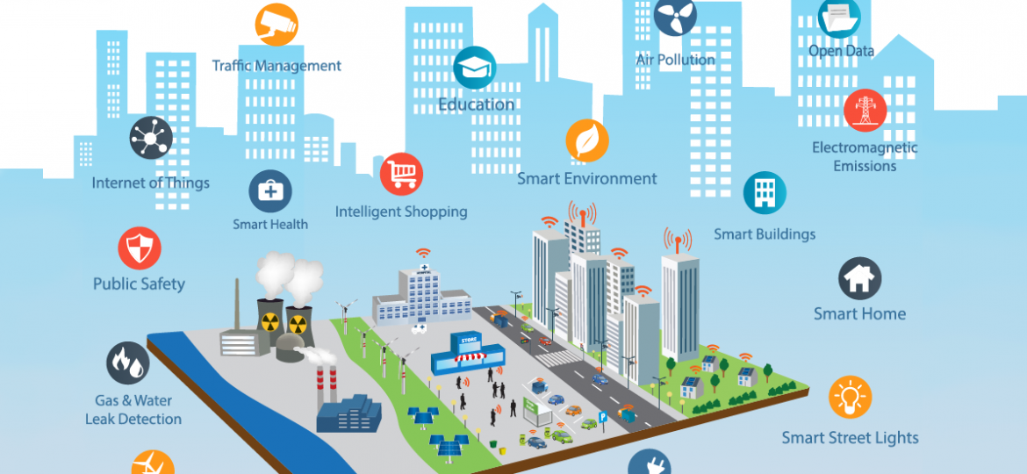

In a smart city, we are using devices like desktop, laptops, mobile phones etc to perform our daily tasks, access information etc. Some of the smart city automated systems are prominent from the figure above. You are required to visualize the daily activities of a system manager working in a software house, living in a smart home fitted with wifi controlled devices and answer the following questions in the light of knowledge you obtained in chapter 1 and 2 of this Operating Systems course :

Q1. Examples of computing machines he uses: /10

1. At home 🡪 desktop, laptop, tablet, mobile
2. In office 🡪 servers , laptops, mobiles
3. During commute🡪 laptops, mobiles

Q2. Give the name of operating systems (centralized/distributed), he might be using and the reason to use that particular system: /10

1. At home 🡪 windows (easy to use) mobile( iOS, Android)
2. In office 🡪 linux (secure, easy to develop, opensource) mobile(same as above)
3. During commute 🡪 android/iOS on mobile

Q3. The architecture of machines , he is using (single core, multicore, symmetric, asymmetric processing) and why?: /10

1. At home (multi core and multiprocessing on desktop and mobile, smp)
2. At office (multi-core, distributed(may or may not), symmetric or asymmetric depending on the organization requirements.
3. During commute (SMP, multicore mobile)

Q4. The examples of computing environment he interacts , the purpose of interaction: /10

1. At home ( client/ server for google, youtube, facebook)
2. At office ( client server for file sharing, print server, database server etc.)
3. During commute (peer to peer for playing music, client server for google maps)

Q5. Give example of task automation that can help a banker /5

1. At home ( Alarm for waking up in the morning, wifi controlled air conditioning etc.)
2. At office ( automated backup at 5 in the evening)

Q6. List two of the APIs that are used frequently by most of the drivers using mobile services during driving. /5

Ans. Google maps API , Siri for sound based commands such as voice calling etc.

Q7. Differentiate: /10

1. Arduino vs Raspberry Pi (in terms of Os memory management and process management)

Ans. Arduino has no OS , a sketch is loaded to run a single task at a time

Raspberry Pi has raspbian, 1 to 4 gb ram, multi-tasking

1. iOS vs Android ( in terms of Graphical User Interface, APIs, system development languages)

as given in book pages

1. emulation vs simulation with example

**Q8. Why applications are operating system dependent? Explain briefly. /5**

Ans. Due to system call interface difference in all operating systems.

Different APIs used in different operating systems.

**Q9. Pick one of the applications shown in smart city and discuss its architecture, computing environment, communication needs in terms of operating system concepts. /30**

Ans. Depends on the application.

Traffic control system requires cluster computing for traffic volume calculation in different parts of city.

Machines required : cameras or sensors for traffic volume control, edge devices, central server

Computing environment: distributed computing with periodic updates to the central control system.

Communication needs. High speed network needed to transmit traffic data. Communication in terms of gps and surveillance by cameras need high speed processing and data tansmission.